Price List
5 March 2019

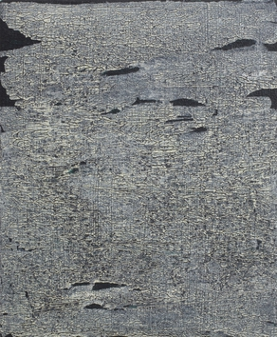 | Manijeh Yadegar 1951-2016  C9-2013, 2013  signed 'Manijeh Yadegar' and inscribed 'C9-2013' (on the canvas overlap)  acrylic on canvas  29.5 x 24 cm  11 5/8 x 9 1/2 in | £ 2,340
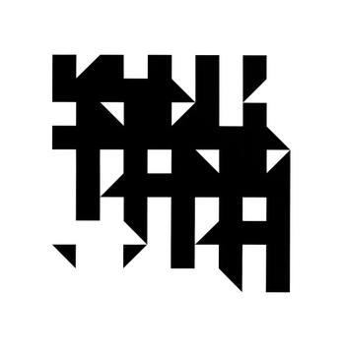 | Kathleen Hyndman 1928  Straight Line Rotation Black on White, 1986  signed, inscribed and dated 'fin.c.27.11.86.STRAIGHT LINE ROTATION.BLACK ON WHITE.(FOREST)/K.M.HYNDMAN' (on the canvas overlap)  acrylic on canvas  76.5 x 76 cm  30 1/8 x 29 7/8 in | £ 4,500
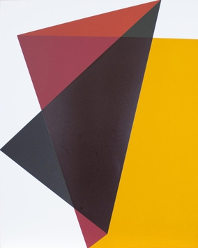 | Willard Boepple b.1945  9.6.16, 2016  screenprint on Somerset Velvet 300gsm  71.5 x 57 cm  28 1/8 x 22 1/2 in  Edition of 25 | £ 1,200
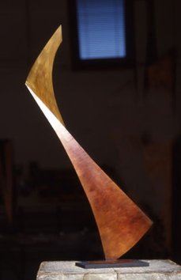 | Graham Williams b.1940  Sinew, 2001  silicon bronze, welded and patinated, on an industrial black plastic base  height 57 cm (22 1/2 in), including integral base | £3500
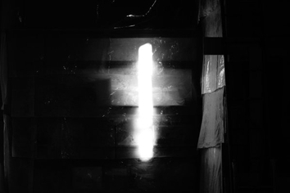 | Amelia Kate Sampson b.1992  INRI  Giclée print on German etching paper  44 x 58 cm  17 3/8 x 22 7/8 in  Edition of 15 | £650
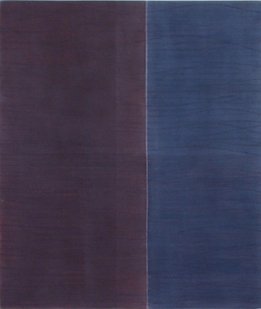 | Rebecca Salter RA b.1955  BB27, 2018  mixed media on muslin on linen  40 x 34 cm  15 3/4 x 13 3/8 in | £ 4,000
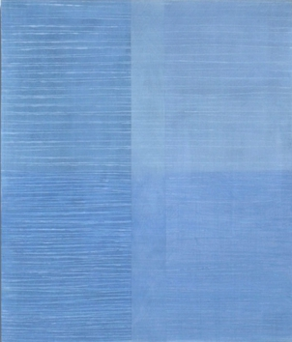 | Rebecca Salter RA b.1955  BB28, 2018  mixed media  40 x 34 cm  15 3/4 x 13 3/8 in | £ 4,000
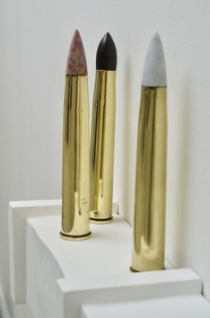 | Amelia Kate Sampson b.1992  Sat Firing Squad MK1  Various stone tipped WW2 brass shell casings  Kilkenny Limestone 350 x 70 x 70 mm  137 3/4 x 27 1/2 x 27 1/2 in  Indian Pink Marble 350 x 70 x 70 mm  137 3/4 x 27 1/2 x 27 1/2 in  Carrara Marble 350 x 70 x 70 mm  137 3/4 x 27 1/2 x 27 1/2 in | £ 2,000
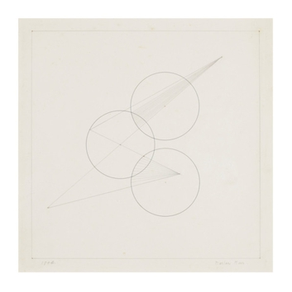 | Marlow Moss (1889-1958)  Untitled (Work on Paper, no.13), 1944  signed and dated  ink on paper  29.3 x 27 cm  11 1/2 x 10 5/8 in | £ 13,500
 | Marlow Moss (1889-1958)  Untitled (Work on paper, no.3), 1943  Ink and gouache on paper  15.8 x 16.5 cm  6 1/4 x 6 1/2 in | £ 13,500
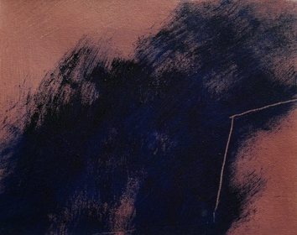 | Susan Pye 1942-2018  Skyscape 1  acrylic on canvas  20.5 x 25.5 cm  8 1/8 x 10 1/8 in | £ 960
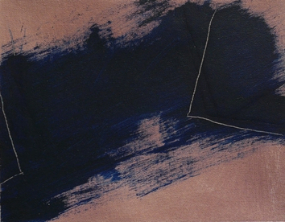 | Susan Pye 1942-2018  Skyscape 2  acrylic on canvas  20.5 x 25.5 cm  8 1/8 x 10 1/8 in | £ 960
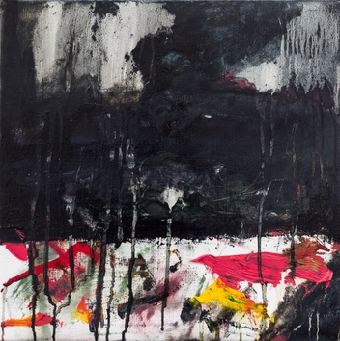 | Frances Aviva Blane b. 1954  Sky  oil on linen  45 x 45 cm  17 3/4 x 17 3/4 in | £5000
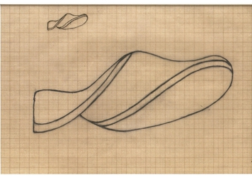 | Naum Gabo 1890-1977  Study for a Carving (D88), c.1931  pencil and pen on graph paper  20.9 x 29.7 cm  8 1/4 x 11 3/4 in | £ 4,000
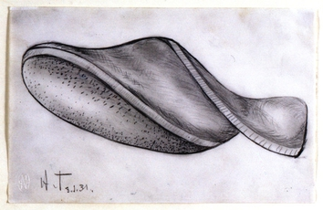 | Naum Gabo 1890-1977  Study for a Carving (D89), 1931  pencil on paper  14 x 22 cm  5 1/2 x 8 5/8 in | £ 4,500
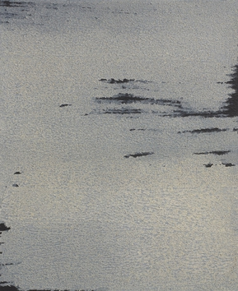 | Manijeh Yadegar 1951-2016  C12-01, 2001  signed 'Manijeh' and with inscription 'C12-01' (on the canvas overlap)  oil on canvas  29 x 24 cm  11 3/8 x 9 1/2 in | £ 2,340
 | Manijeh Yadegar 1951-2016  C22-00, 2000  signed 'Manijeh' and with inscription 'C22-00' (on the canvas overlap)  oil on canvas  20.2 x 20 cm  8 x 7 7/8 in | £ 1,740
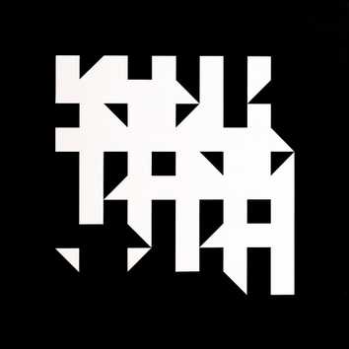 | Kathleen Hyndman 1928  Straight Line Rotation, White on Black.Forest, 1986  signed, inscribed and dated 'K.M.HYNDMAN.fin.1.12.86/STRAIGHT LINE ROTATION.WHITE ON BLACK.FOREST' (on the canvas overlap)  acrylic on canvas  76.5 x 76.5 cm  30 1/8 x 30 1/8 in | £ 4,500
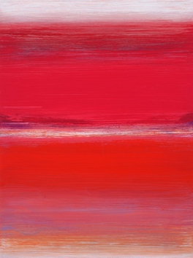 | Trevor Sutton b.1948  Anywhere Road, 2006  oil on board  51 x 38 cm  20 1/8 x 15 in | £ 6,000
 | Trevor Sutton b.1948  Vista, 2016  oil on board  63.5 x 183 cm  25 x 72 1/8 in | £ 12,000
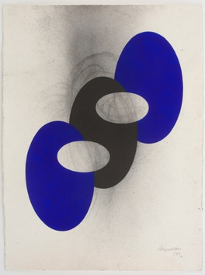 | Nigel Hall R.A. b. 1943  Drawing 1788, 2018  acrylic and charcoal on paper  76 x 56.5 cm  29 7/8 x 22 1/4 in | £ 5,100
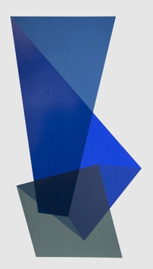 | Willard Boepple b.1945 Benington, Vermont  2.6.16, 2016  screenprint on Somerset Velvet 300gsm  90.5 x 55.5 cm  35 5/8 x 21 7/8 in  Edition of 25 | £ 1,200
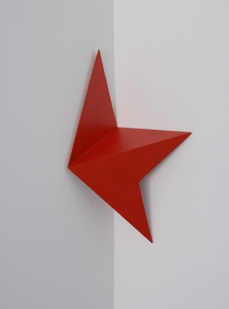 | George Meyrick (b.1953)  Tautology IV, 2013  painted plywood  51.5 x 51 x 35.5 cm  20 1/4 x 20 1/8 x 14 in | £ 1,080
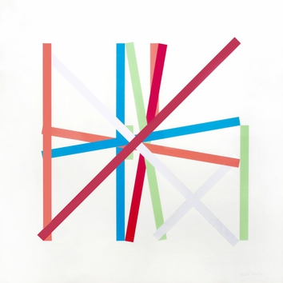 | Kenneth Martin 1905-1984  Rotation Frankfurt III, 1977  signed, dated and numbered in pencil  screenprint  54.5 x 55 cm  21 1/2 x 21 5/8 in | £3500
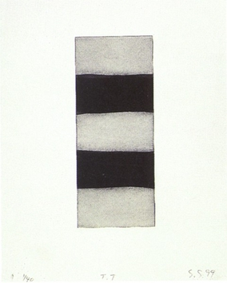 | Sean Scully b.1945  Ten Towers IX, 1999  Etching with aquatint  Paper 38.1 x 27.9  Image 25.4 x 10.2 cm  Paper 15 x 11 in | £3000
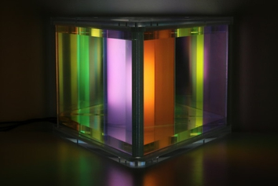 | Liz West b.1985  Our Spectral Vision Maquette, 2016  acrylic, polycarbonate tubes, LEDs and dichroic glass  21.5 x 29.3 x 32.5 cm  8 1/2 x 11 1/2 x 12 3/4 in  Edition of 3 plus 1 artist's proof | £ 4,500
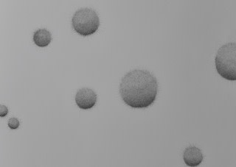 | Frederike von Cranach (b. 1976)  Idyl or Illusion?, 2018  ink drawing on Somerset paper  68 x 52 cm  26 3/4 x 20 1/2 in | £ 2,520
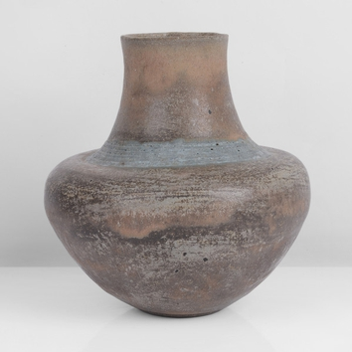 | Lucie Rie 1902 - 1995  Pot, 1970  impressed LR seal  Stoneware, mottled brown dolomite glaze, a band of turquoise glaze over horizontal sgraffito above the stepped shoulder  height 16.5 cm  height 6 1/2 in | £ 10,500
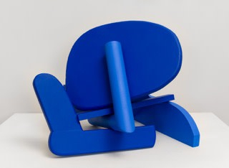 | Willard Boepple b.1945  Buba, 2018  oak  16 in x 21 in x 21 in | £ 7,200
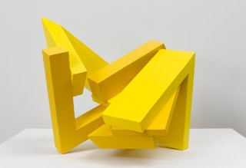 | Willard Boepple b.1945  Nelson, 2018  oak  16 1/2 in x 17 in x 20 1/2 in | £ 7,200
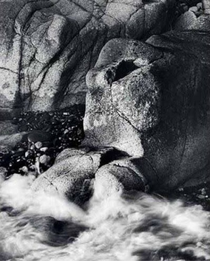 | Ander Gunn (b. 1933)  Sea Sphinx, 1993  photograph edition 50  50.9 x 40.5 cm  20 1/8 x 16 in | £ 675
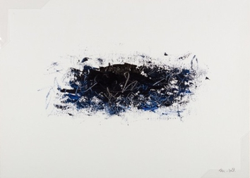 | Martha Green Doran (b. 1953)  Midnight, 2008  acrylic on canvas  27 x 37 cm  10 5/8 x 14 5/8 in | £ 800
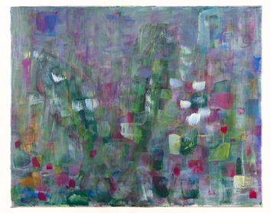 | Martha Green Doran (b. 1953)  Wings, 2017  acrylic on linen  44 x 54 cm  17 3/8 x 21 1/4 in | £ 1,100
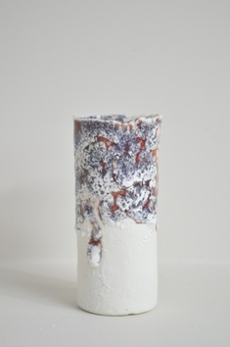 | Nadine Bell (b.1961)  Chilled  porcelain  10 x 4 cm  4 x 1 5/8 in | £250
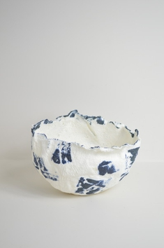 | Nadine Bell (b.1961)  Memories  porcelain  10 x 15 cm  4 x 5 7/8 in | £ 500
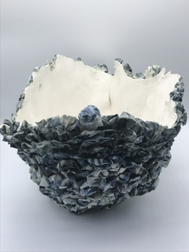 | Nadine Bell (b.1961)  Nomad  porcelain  27 x 44 cm  10 5/8 x 17 3/8 in | £1400
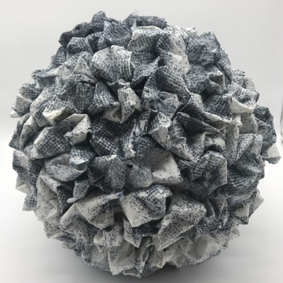 | Nadine Bell (b.1961)  Blue Sprinkle  porcelain  30 x 30 cm  11 3/4 x 11 3/4 in | £ 1,300
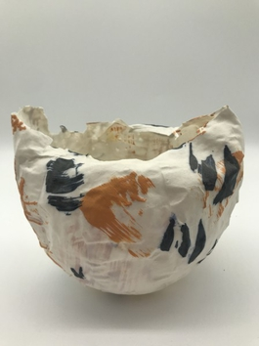 | Nadine Bell (b.1961)  Ho Chunk  porcelain  13 x 16 cm  5 1/8 x 6 1/4 in | £ 600
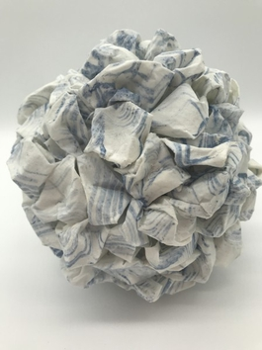 | Nadine Bell (b.1961)  Blue Wave  porcelain  20 x 20 cm  7 7/8 x 7 7/8 in | £800
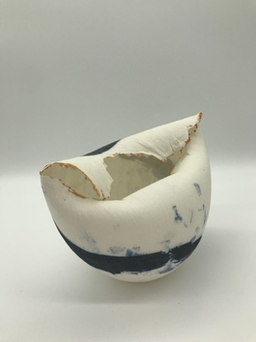 | Nadine Bell (b.1961)  Heat  porcelain  10 x 17 cm  4 x 6 3/4 in | £500
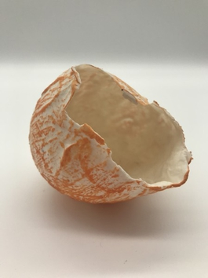 | Nadine Bell (b.1961)  Burning Passion  porcelain  8 x 8 cm  3 1/8 x 3 1/8 in | £ 300
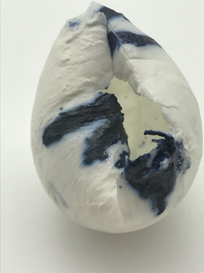 | Nadine Bell (b.1961)  Mellow  porcelain  7 x 6 cm  2 3/4 x 2 3/8 in | £ 300
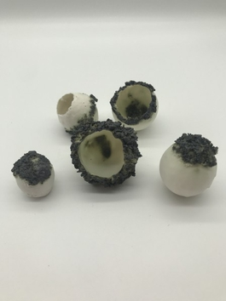 | Nadine Bell (b.1961)  Molluscs  porcelain  5 x 4 cm  2 x 1 5/8 in | £ 350
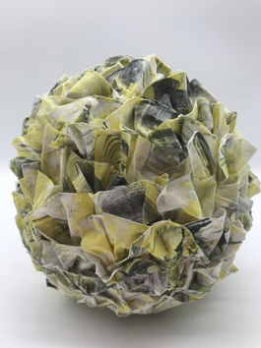 | Nadine Bell (b.1961)  Jagged Curves  porcelain  20 x 20 cm  7 7/8 x 7 7/8 in | £800
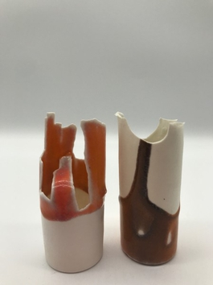 | Nadine Bell (b.1961)  Twisted Sisters  porcelain  10 x 5 cm  4 x 2 in | £350
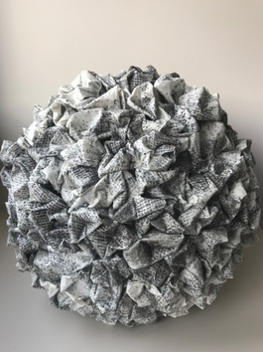 | Nadine Bell (b.1961)  Purple Sprinkle  porcelain  30 x 30 cm  11 3/4 x 11 3/4 in | £ 1,300
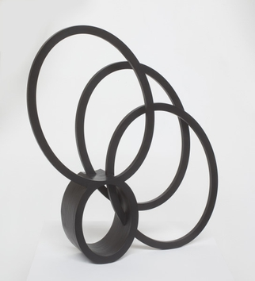 | Nigel Hall RA b. 1943  Little Southern Shade IV, 2018  bronze with black patina  60 x 55 x 10.7 cm  23 5/8 x 21 5/8 x 4 1/4 in | £ 21,600

